Data pepration in weka

Data preparation in Weka is done to ensure that the data is clean, consistent, and suitable for the machine learning algorithms. Proper preparation helps to improve the accuracy and efficiency of models by addressing issues like missing values, scaling features, and encoding categorical data.

After loading the datasets,we can do data preprocessing.

After preprocessing classification or regression can done.

For preprocessing the we should apply some filters.

***Load the dataset .***

Open file/windows c:/program files/weka 3.9.6/data/choose the dataset .

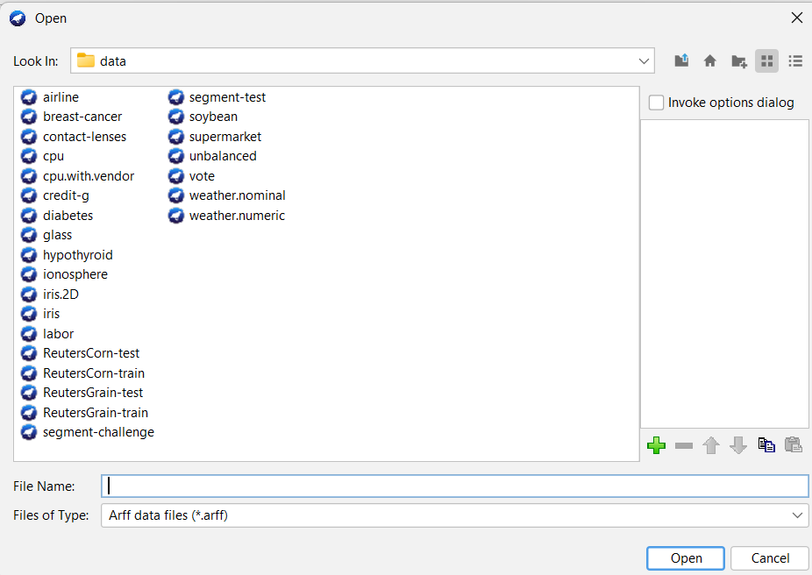

Choose any dataset to to load and click open.

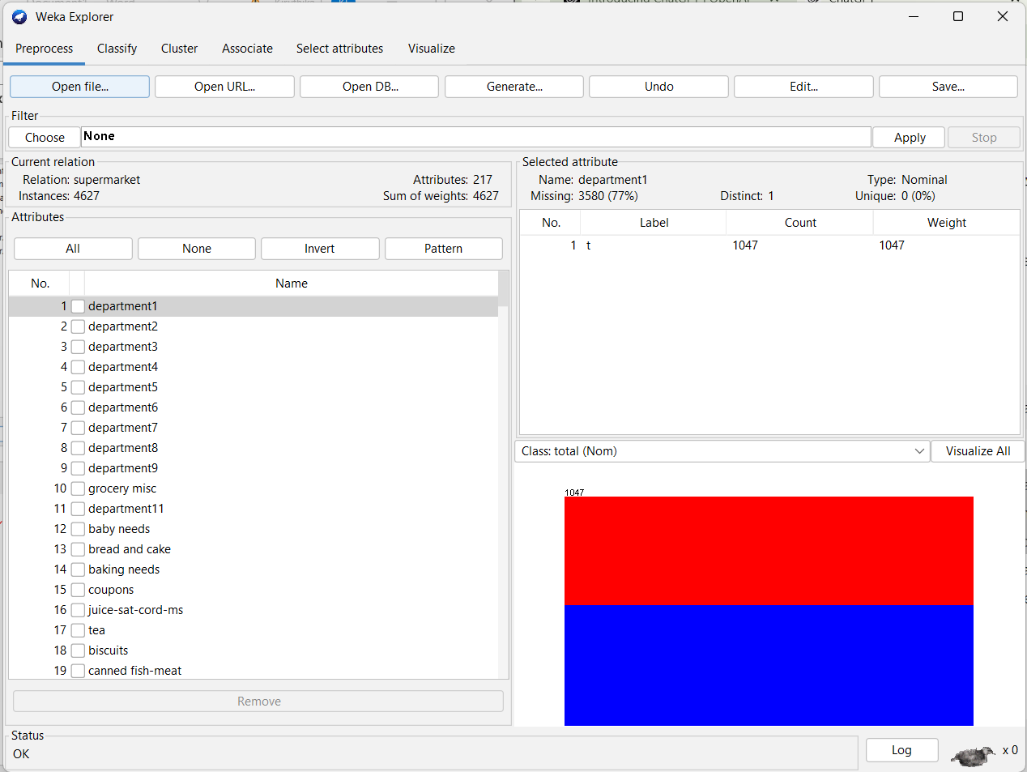

Then in the filter click on choose to apply filter.

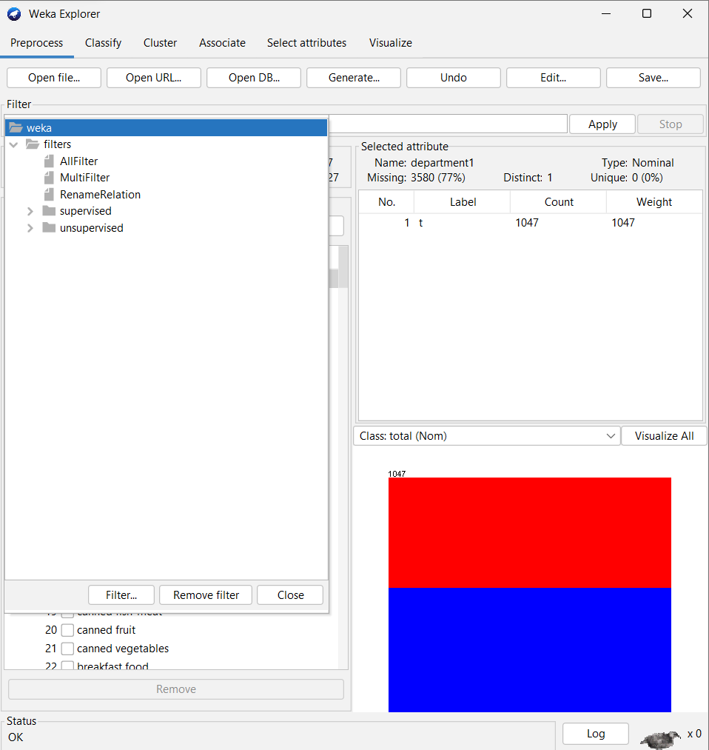

We can also load dataset using URL

Click open URL / give the url / click ok

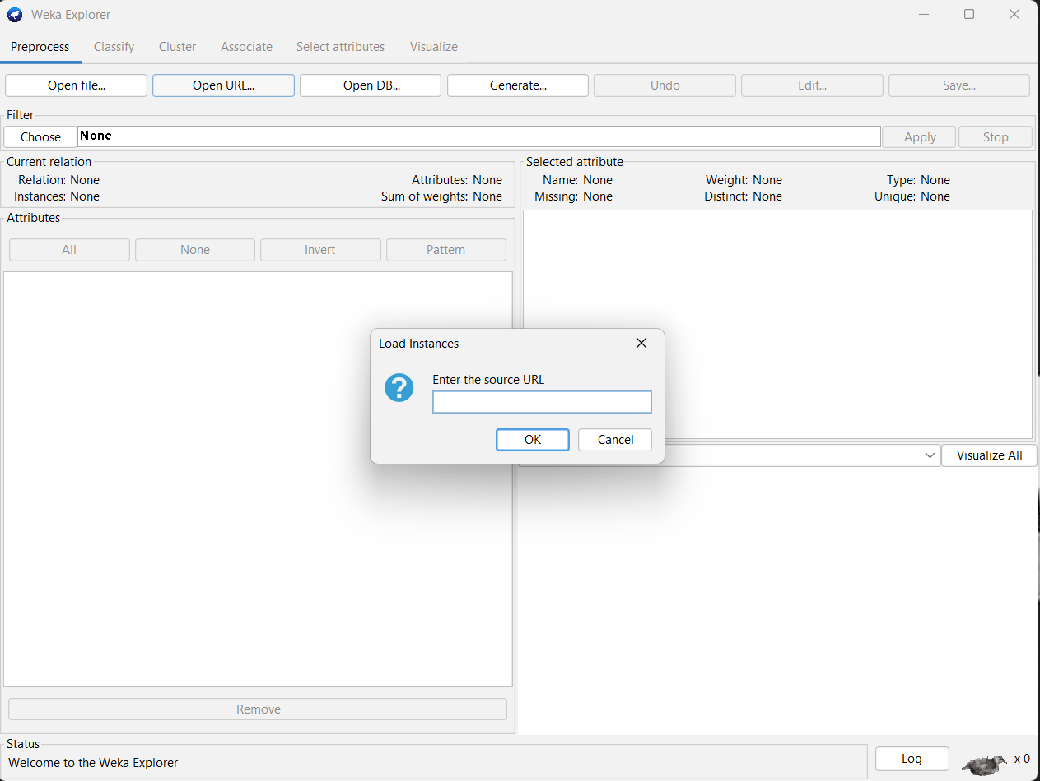

Enter the source URL and click ok to datasets

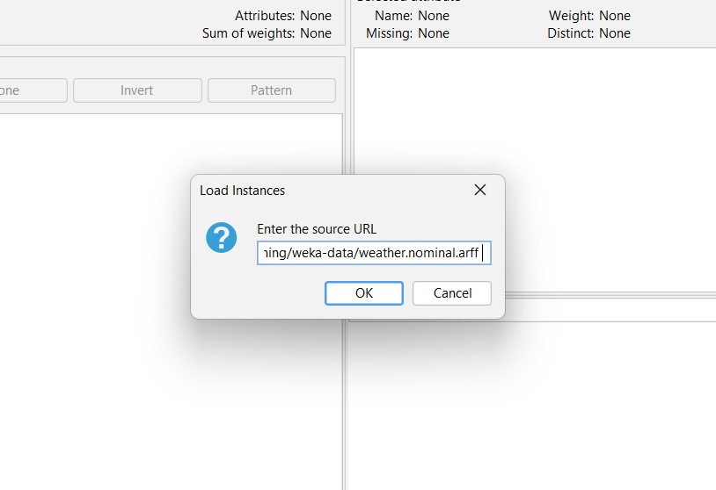

Click ok

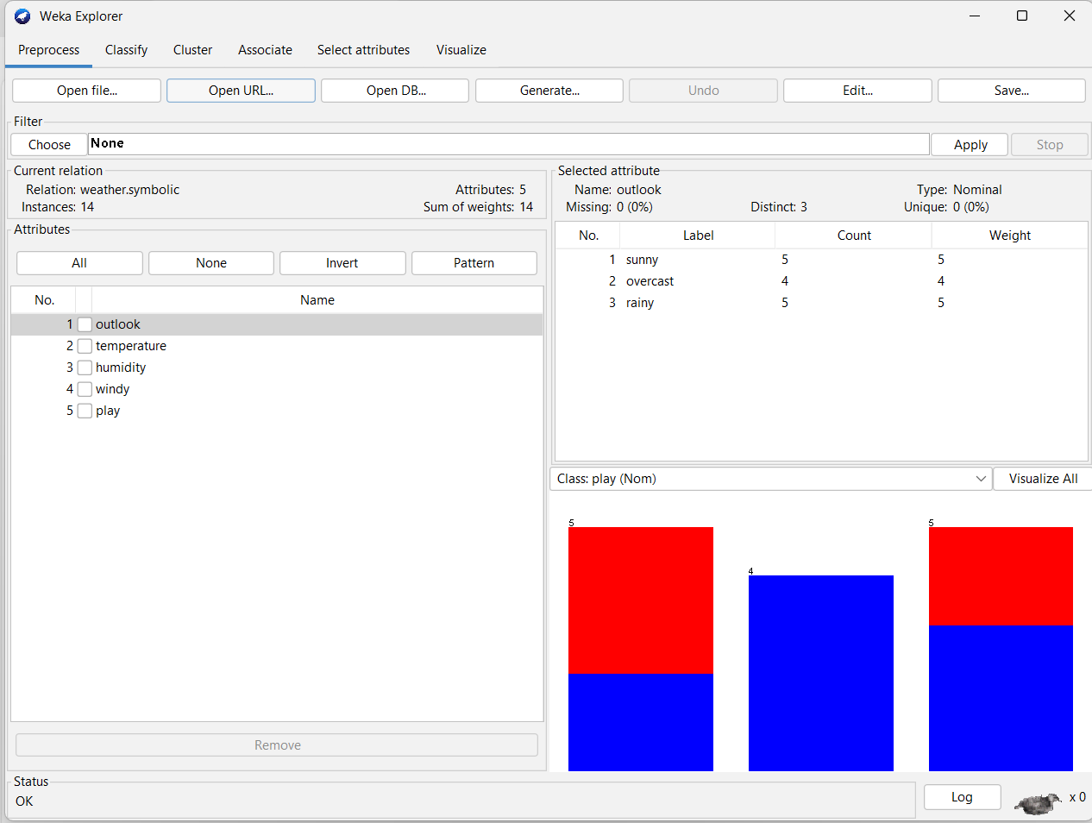

**Allfilter in filter**

Hera all filter is applied to the datasets.

**Purpose**: Applies a sequence of filters in a specified order.

**Functionality**: Filters are applied one after another. The output of one filter becomes the input for the next filter in the sequence. This is useful when the order of operations affects the outcome, such as when one filter's output is required as the input for another.

Choose\filter\allfilter.

Click on apply to excute the filter

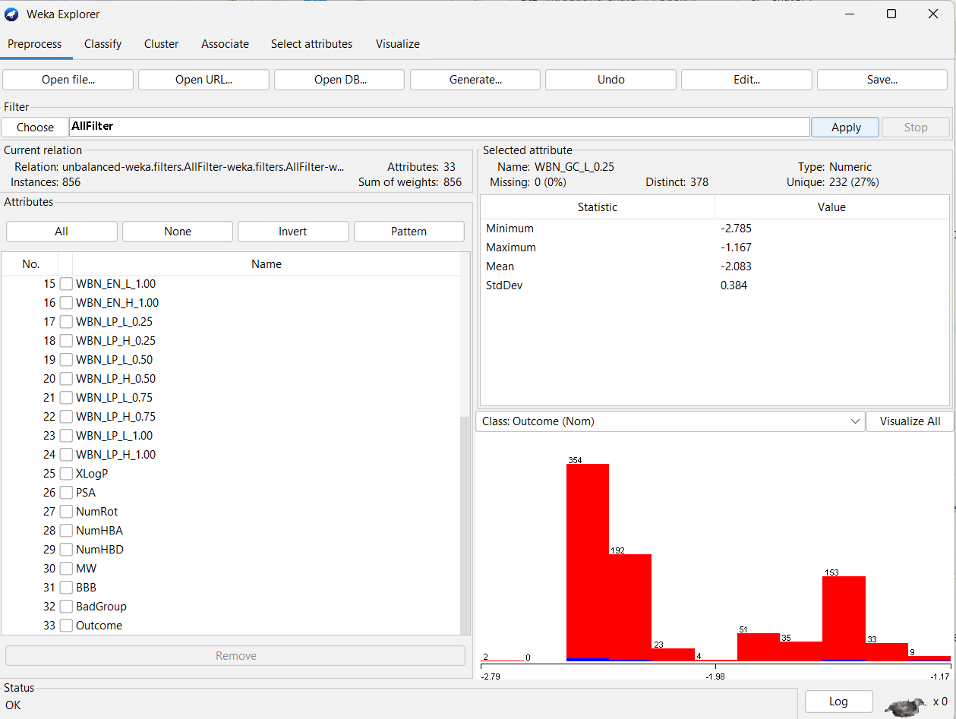

**Multifilter in weka**

**Purpose**: Applies multiple filters simultaneously.

**Functionality**: All selected filters are applied concurrently to the dataset. Each filter operates independently, and the filters do not influence each other’s output. This is useful for applying independent preprocessing steps simultaneously.

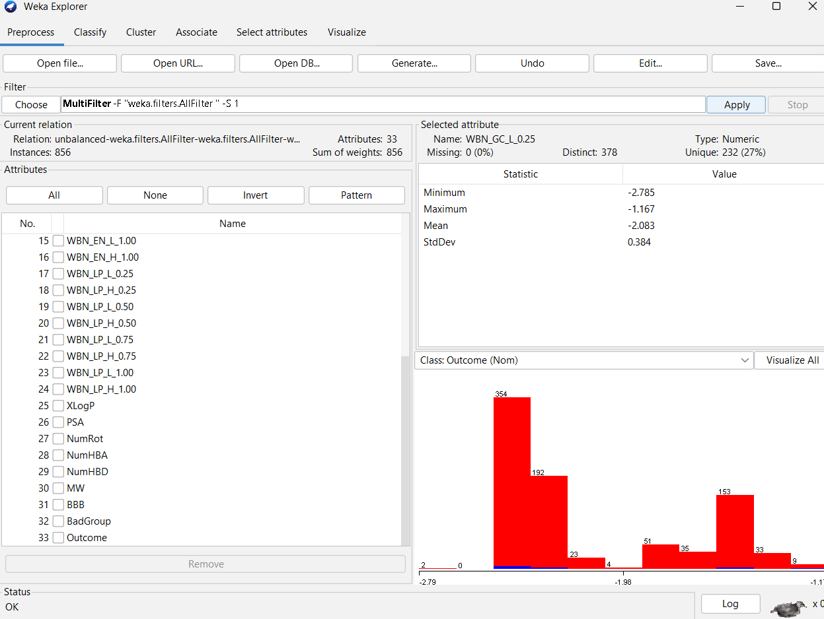

Right click multifilter to add filter

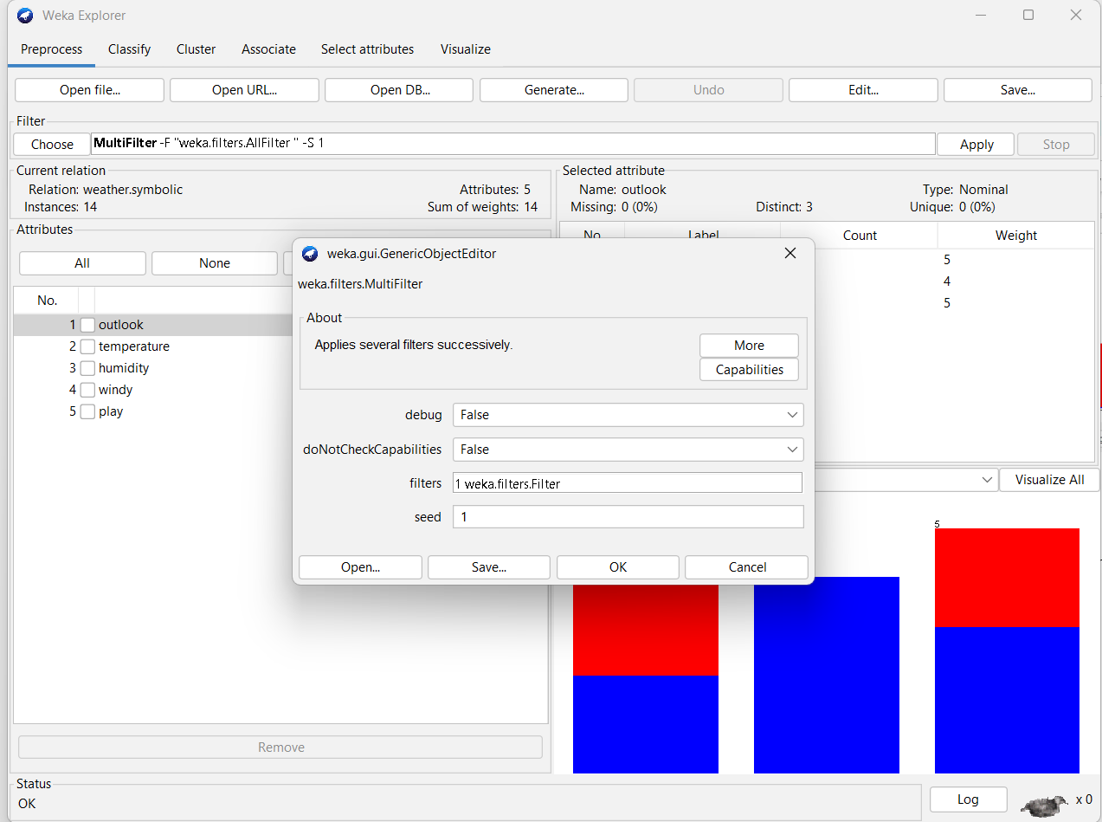

Click filter.

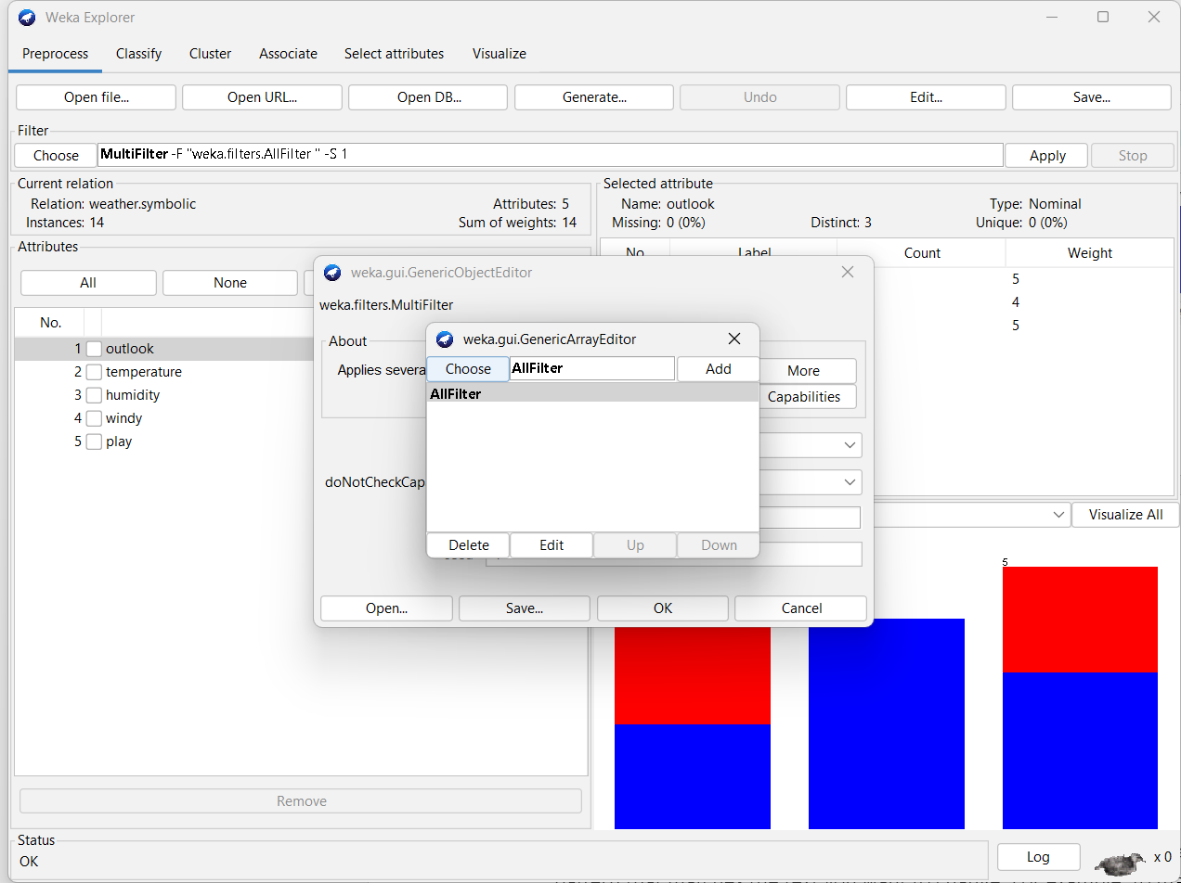

Click choose and select the the filters which we want apply. And add it

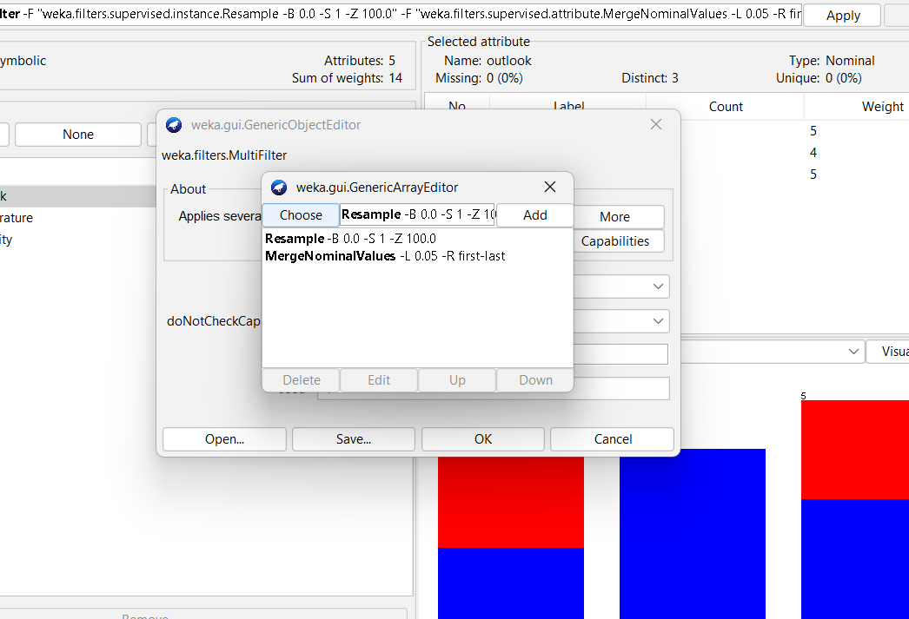

Click ok and apply to use the selected filters . The selected filters are applied to the dataset parallelly.

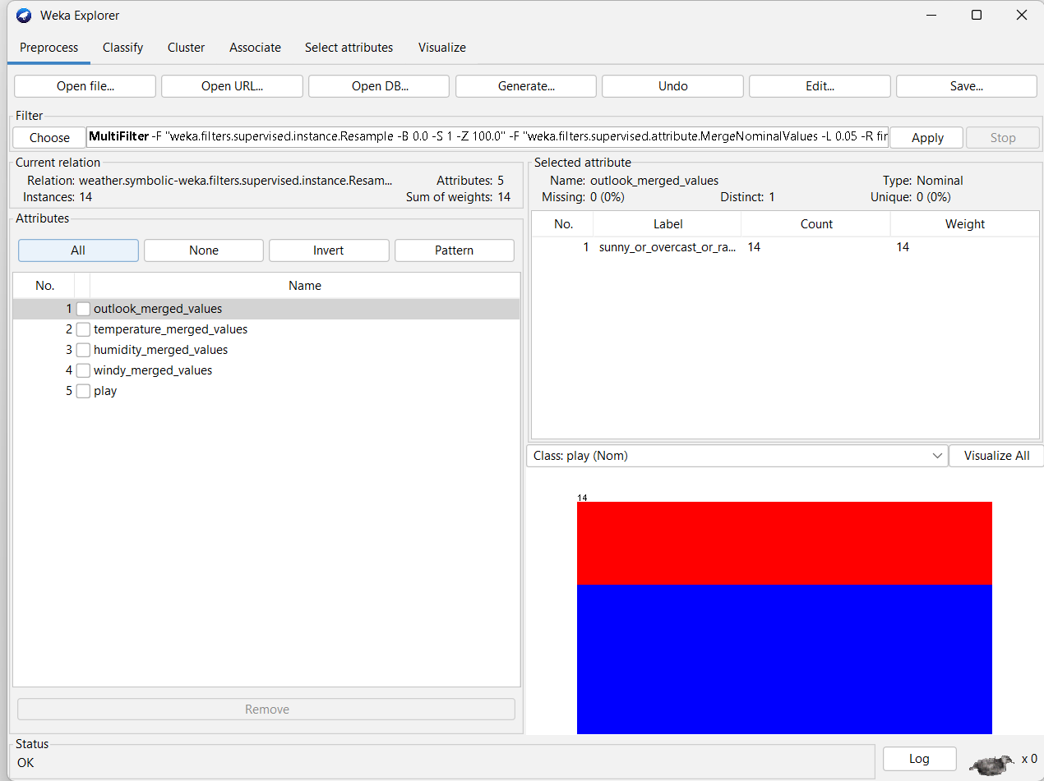

To see the dataset after applying the filter select edit option

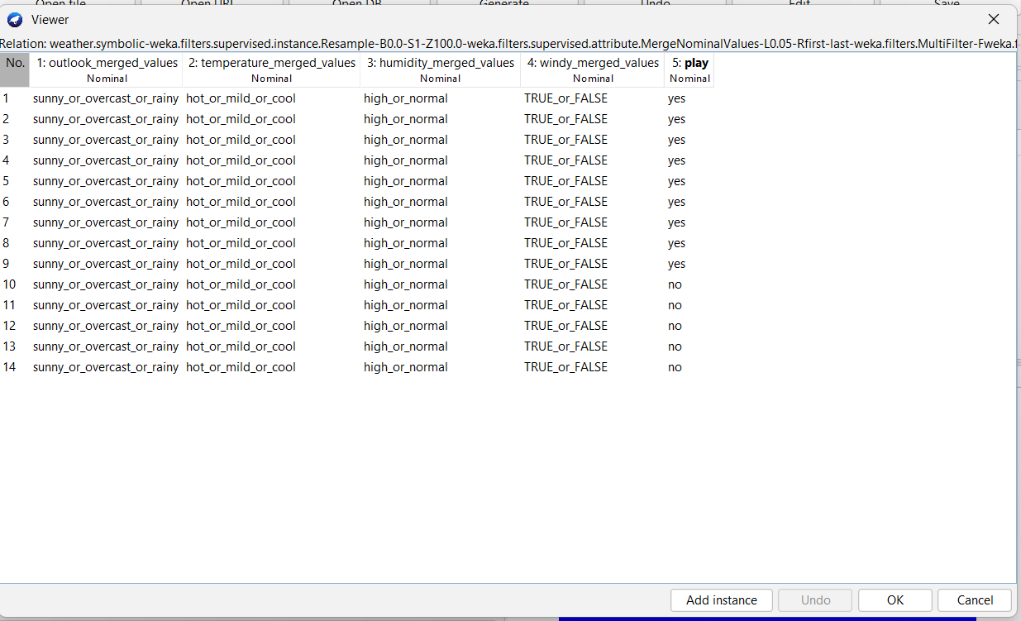

**Rename relation**

A filter that allows the relation name of a set of instances to be altered.

**Define the Pattern:**

* In the RenameRelation filter configuration, you provide a regular expression pattern that matches the text you want to change. For example, to match any relation name starting with "Old", you might use the pattern ^Old.*.

**Specify Replacement:**

* Provide a replacement text that will replace the matched text. The replacement can include backreferences (like $1) to parts of the original text matched by groups in the regex pattern.
* **Example**: Using a pattern like ^Old(.*) and a replacement like New_$1 will replace "OldName" with "New_Name", where $1 refers to the part of the name matched by (.*).

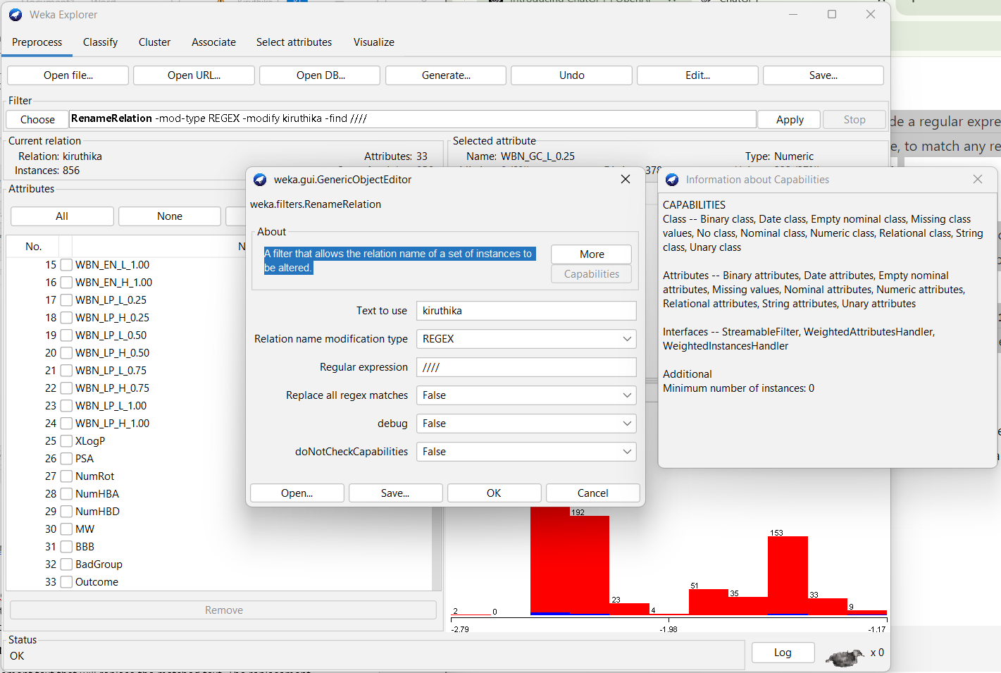

^ : Matches the start of the string.

$ : Matches the end of the string.

. : Matches any character except a newline

\d : Matches any digit.

\w : Matches any word character (alphanumeric and underscore).

**supervised**

"supervised" refers to a category of filters and methods that utilize the class attribute (or target variable) in their operations. These filters are specifically designed to process and prepare data with consideration of the outcome variable that you are trying to predict or classify.

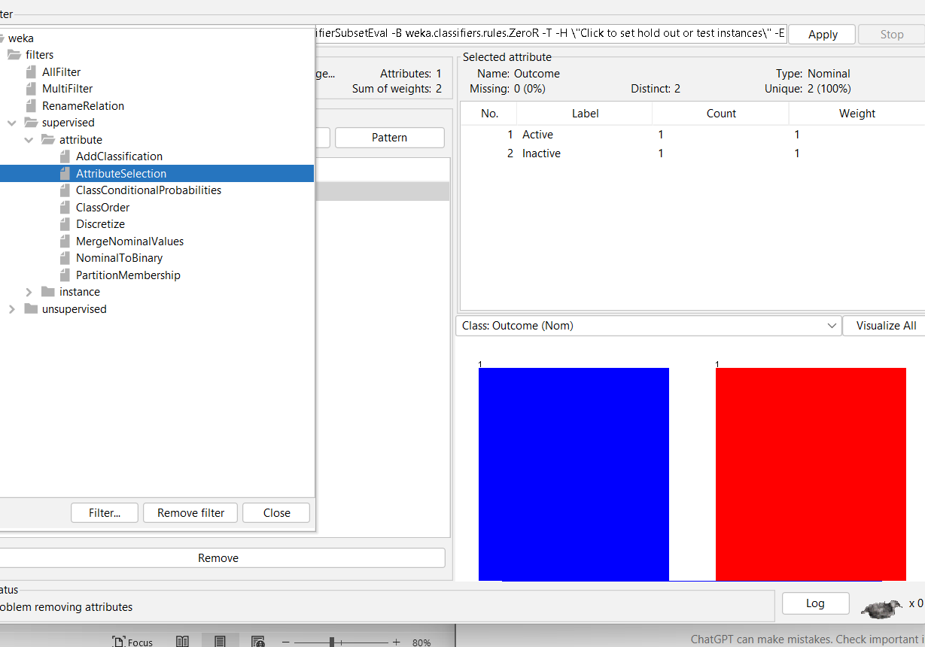

**Attribute filter**

in Weka, attribute filters are used to modify or select attributes in your dataset to prepare it for machine learning. These filters can help in tasks like selecting relevant attributes, removing irrelevant ones, or transforming attributes into a format better suited for modeling.

Example:

**Discretize Filter**

* **Description:** Converts continuous attributes into discrete bins or categories based on their values.

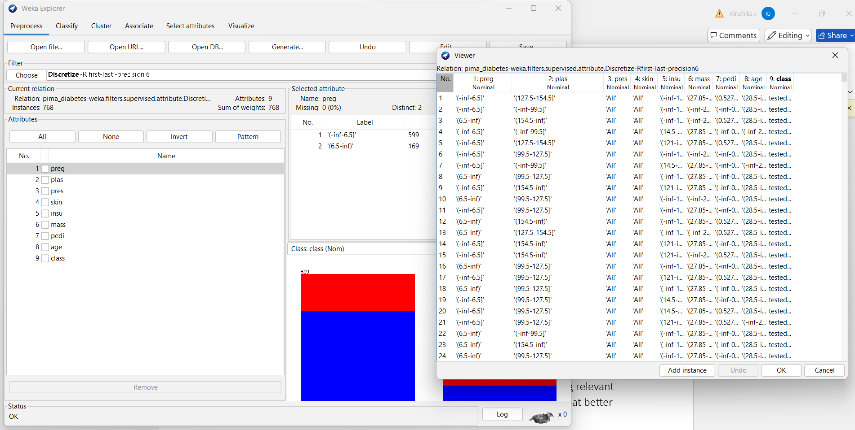

Instance filter:

In Weka, instance filters are used to modify or select instances (rows) in your dataset. They allow you to perform various operations such as sampling, resampling, or removing instances based on specific criteria. This can be especially useful for tasks like handling imbalanced datasets, splitting data, or performing data augmentation.

Example:

Resample

**Description:** Creates a new dataset by resampling the original dataset. This can be done with or without replacement and allows you to specify a sampling ratio.

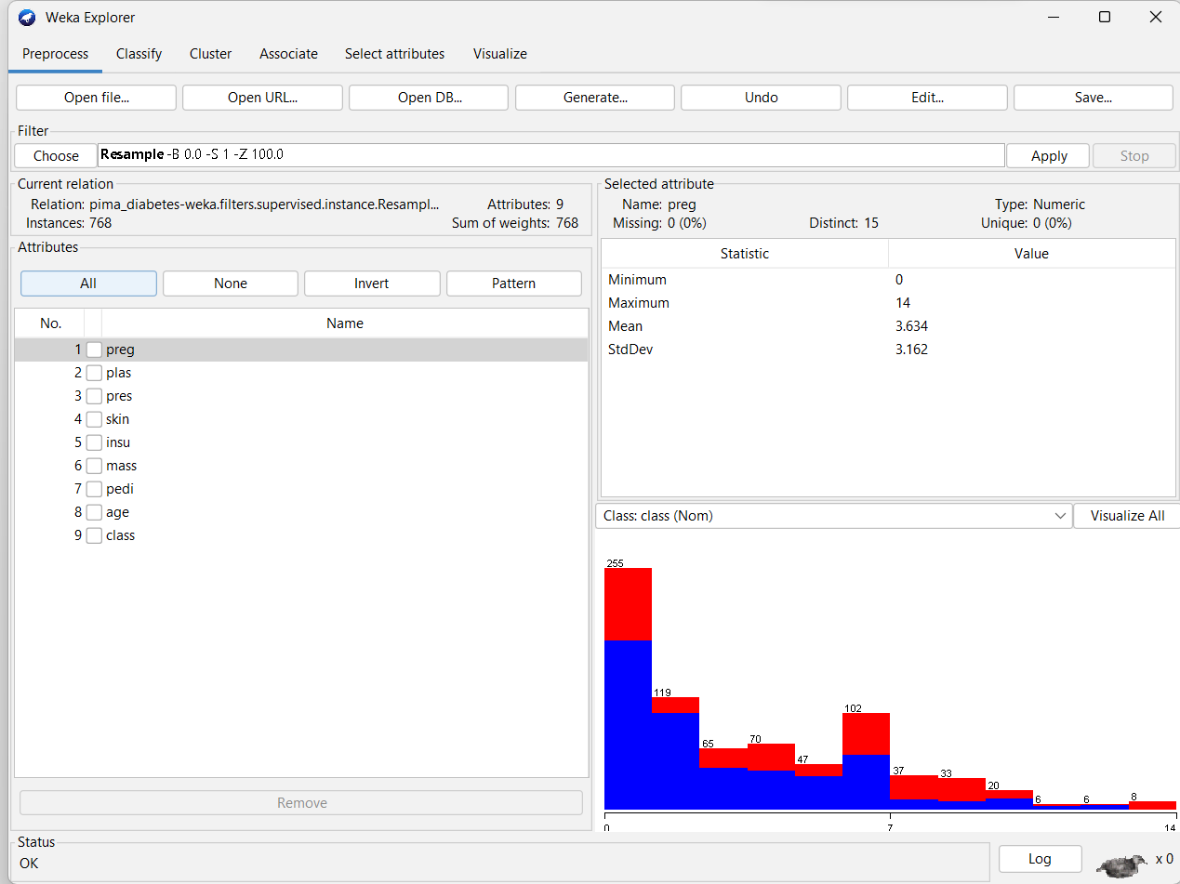

Unsupervised filter

**unsupervised filters** are used to preprocess and transform data without utilizing any information about the class attribute (target variable). These filters operate purely based on the attributes of the data, and their primary goal is to process or clean the data in a way that helps improve the quality and suitability of the dataset for analysis or modeling.

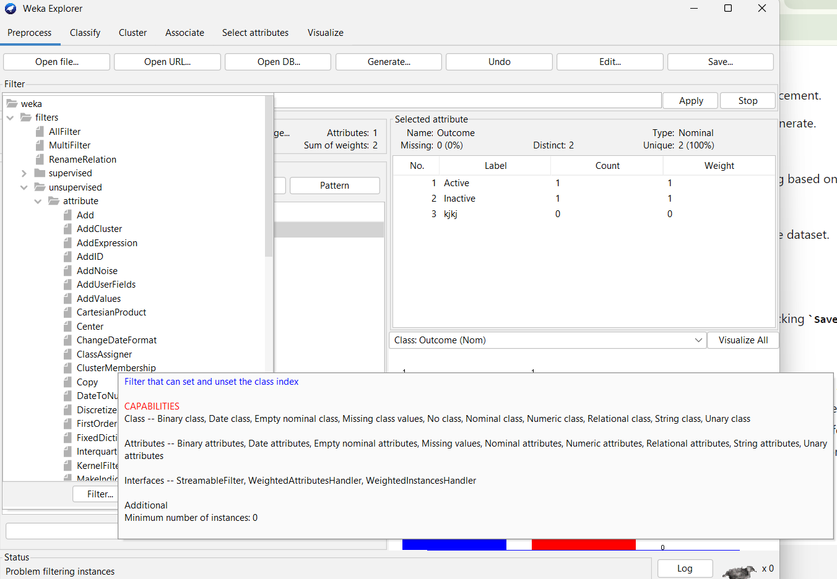

Attributefilter :

In Weka, **attribute filters** in the context of **unsupervised filters** are used to preprocess and transform the attributes (features) of your dataset without considering the class attribute. These filters focus solely on the attributes themselves and perform operations such as scaling, normalization, dimensionality reduction, or transformation based on unsupervised methods.

**Normalize Filter**

* **Description:** Scales numeric attributes to a standard range, typically [0, 1].

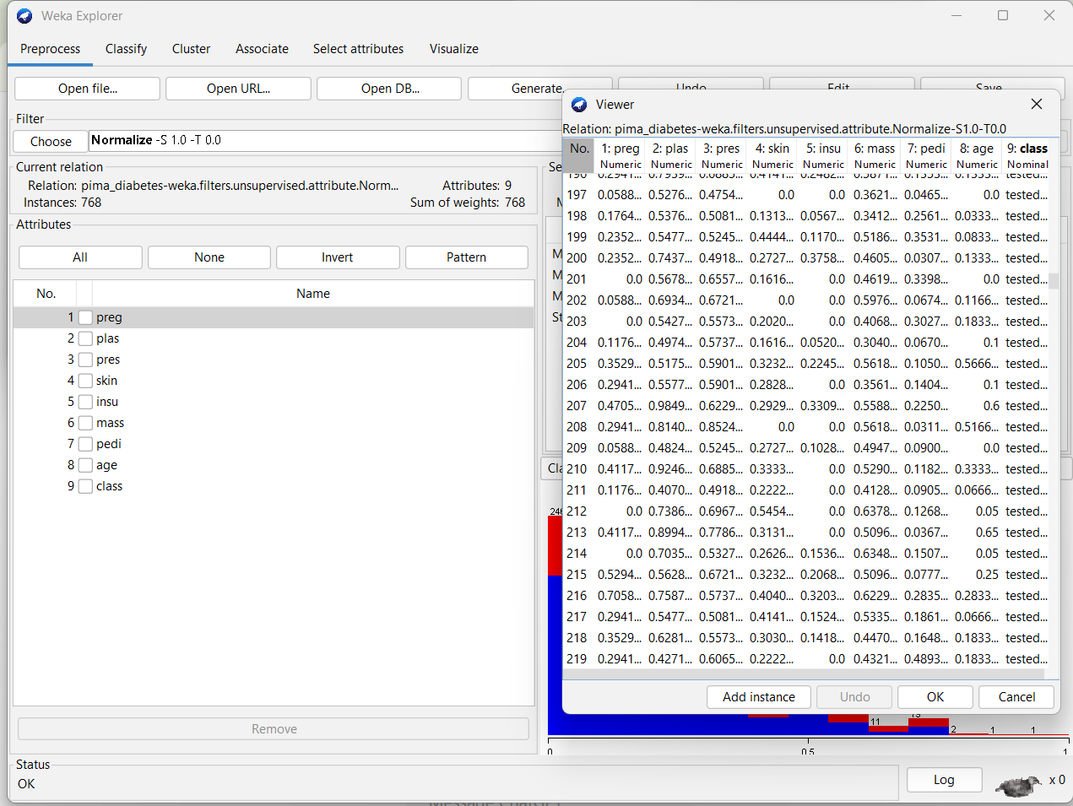

**Instance filter:**

These filter are applied to the instances of the datasets without utilizing the class attribute.

Example:

Remove range :

Remove the instances based on the range fiven in the filter.

